INTERNATIONAL WOMEN'S RIGHTS DAY 2023: FOCUS ON ALICE CARRIER

On the occasion of the Women's Rights Day, the CRCM gives the floor to Alice Carrier, member of the center's parity unit, to address the issue of the position of women in the research world.

What are your duties and responsibilities at the Cancer Research Center of Marseille?
I am a CNRS Research Director. At the CRCM, I lead a research group that works to improve treatments for pancreatic cancer patients. My tasks are multiple, they mainly consist in defining the research programs, supervising the students and post-doctoral fellows who carry out these projects, finding funding to be able to carry them out, and finally disseminating the fruit of these researches to the scientific community and to the society.

How can we describe the place of women in research?
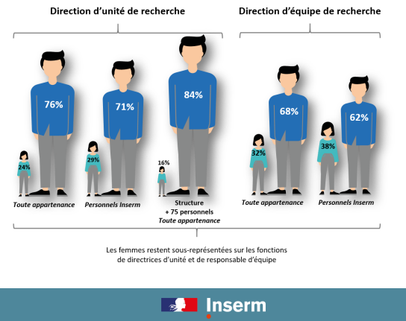
I can give you an overview of this question for Inserm, which is a national scientific and technological public institution and one of the 4 supervisory bodies of the CRCM*. At Inserm, the majority of staff are women (59%), but this observation masks a great disparity: women are over-represented among engineers and technicians (69%) and on the other hand they are in the minority in research positions (47%). When we look at positions of responsibility such as team and laboratory management, the higher up the hierarchy of positions, the lower the proportion of women; for example, only 24% of Inserm unit directors are women. The situation is identically unbalanced at CNRS, which is another of our supervisory bodies.

Can you describe the situation in terms of equity?
Women have a harder time than men getting promoted. For example, in the category of researchers, women represent 51% of research fellows but only 39% of research directors. It should be noted that all the imbalances observed at Inserm and CNRS at the national level are also observed at the local level in our university and in our research center.
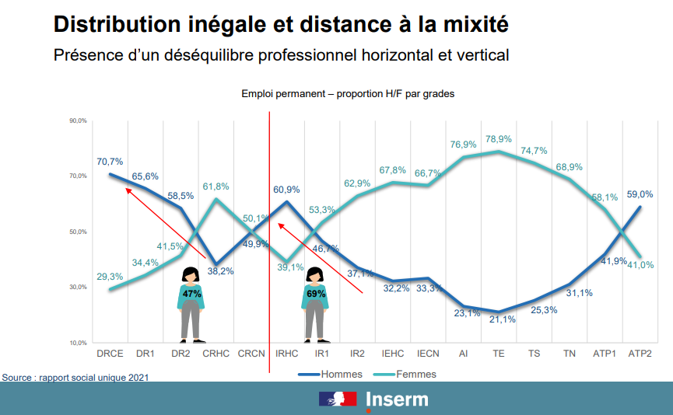

On the basis of this observation, it seems obvious to implement actions to correct these inequalities; what are you doing to improve this situation?
First of all, I responded favorably to the Inserm's call for volunteers to create a Parity and Professional Equality (PEP) committee in our center, whose general mission is to participate in the local implementation of the Plan for professional equality between women and men published by the Inserm in December 2020. This plan aims to fight against the imbalance between women and men observed in higher education and research. Thus, with 7 CRCM colleagues (5 women and 3 men; 3 engineers, 4 researchers and 1 teacher-researcher), we have created the CRCM PEP committee in June 2021.
All the actions envisaged in this plan are designed to promote gender parity. Most of them will also be mobilized to fight against other forms of discrimination (racism, anti-Semitism, anti-LGBT Q+ hate). The role of the PEP unit is to relay the campaigns locally, to propose actions, to lead the reflection and to follow the progress of the structure with regard to parity. Our first actions are all part of a communication objective to promote awareness of imbalances, which is necessary for an evolution towards balance. The first actions initiated are a seminar by Professor Isabelle Régner, a specialist in the effects of gender stereotypes (May 2022), and the launch of a newsletter published twice a year containing information on the imbalances between women and men in different disciplines (science, sport, art, culture, etc.) in a way that combines humor and seriousness. Other actions are being set up such as making documents and articles dealing with the issue available on the center's website, organizing other seminars, etc. Finally, each member of the cell follows training courses that aim essentially to improve knowledge on imbalances and learn how to transmit this information because the topic is tricky.

What more would you like to do?
We still have a lot of work to do in order to communicate on the imbalances and the psychological and societal factors that are responsible for them. To this end, we have initiated a partnership with the Paoli-Calmettes Institute, the cancer hospital that hosts our research center and with which we conduct translational research projects, since the same imbalances as in research are observed in the hospital. And above all, beyond communication actions, we are accompanied by our supervisory bodies to develop proposals to improve our structure in terms of parity. One of the first proposals that has already been implemented is the feminization of the governance of the center, since I am taking on the responsibility of deputy director for the next mandate, which begins in January 2024!

*The Cancer Research Center of Marseille (CRCM) is affiliated with Inserm (UMR1068), CNRS (UMR7258), the University of Aix-Marseille (UM105) and the PACA region's center for the fight against cancer, the Institut Paoli-Calmettes (IPC). For more information https://www.crcm-marseille.fr/

